An Overview of Alzheimer’s Disease

Makenna Collins

IUPUI - N261

Perhaps one of the most daunting memory-related diseases to plague the world, Alzheimer’s disease continues to puzzle scientists through their studies, searching persistently for the cause of this neurological disorder. In 1906, a German physician by the name of Dr. Alois Alzheimer had a patient displaying memory loss (Alzheimer’s Association Staff, n.d.). Following Dr. Alzheimer's death, his patient would soon be recognized as the first case of Alzheimer’s disease following a biopsy that showed shrinkage in nerve cells. According to the Mayo Clinic staff, Alzheimer’s disease is currently the most common cause of dementia, which is a decline in one’s cognitive abilities, memory, social skills, and more (Mayo Clinic Staff, 2024). They also state that approximately 6.5 million people above the age of 65 live with Alzheimer’s, while the upper 70% of that population is over 75 years old. The disease itself is defined as a brain disorder that progressively worsens as time goes on. In short, Alzheimer’s is caused by brain shrinkage and brain cell death, leading to the common defining symptom of memory loss. Although one of the most common diseases, as stated above, the treatments are scarce, leaving this disease at the forefront of biomedical research (Alzheimer’s Association Staff, n.d.). Here, we will dive into the disease as a whole, discussing the symptoms, the potential cause at a neurological level, the overall effect on the individual and those around them, and the multitude of scientists’ developing research to find the true cause and a cure for Alzheimer’s disease.

There are various types of Alzheimer’s disease, distinguished mostly by the timing of onset. According to Mario Mendez, early onset and late onset are the two most seen types (Mendez, 2019). Early onset is classified as being diagnosed under the age of 65; this type is rare, and is seen in less than 5% of patients with the disease. This type is sometimes seen in people with Down Syndrome, having links to deficiency in chromosome 14. Late onset is much more common, impacting the majority of people with the disease after age 65. This form of Alzheimer’s disease is considered sporadic, although genetics could play a role in its infection likelihood. WebMD also mentions Familial Alzheimer’s Disease, or FAD, which is the most scarcely seen, affecting nearly 1% of patients. This form of Alzheimer’s is positively linked to genes, which will soon be discussed further. Symptoms of Alzheimer’s disease and a diagnosis often come much later than the onset of its invasion in the brain (Mayo Clinic Staff, 2024). They also state that the most common symptom seen in individuals, and usually the earliest noticed, is memory loss. Although memory loss comes with age, the effects of Alzheimer’s are much more severe than typically seen within the elderly population. This symptom persists and worsens with the progression of the disease and its infection on the body. More specific examples include repeating statements, forgetting recent conversations, misplacing items, and once becoming severe, forgetting names of loved ones. Other symptoms stated are impairment in thinking and reasoning, judgment, and decision-making; this symptom is apparent towards the beginning of diagnosis and progressively worsens, as well (Mayo Clinic Staff, 2024). Changes in personality and behavior result from these symptoms, leading to possible depression, mood swings, anger, wandering, and more. Although the true cause of Alzheimer’s Disease is not entirely known, the symptoms associated have given some insight as to what changes are occurring and where those changes are happening in the brain.

Clinical trials and research have been conducted to find the underlying cause of AD, leading to a probable overarching idea of the changes at a neurological level. Patients with Alzheimer’s show a high amount of amyloid plaques and neurofibrillary tangles in brain scans (Knapskog, 2021). These amyloid plaques are found extracellularly and are insoluble, leading to neuron damage. Neurofibrillary tangles are the result of phosphorylated tau proteins, found in excessive amounts in important brain regions. When neurons and receptors become damaged, brain cell death is ultimately the consequence. Examination of spinal fluid in patients with Alzheimer’s compared to a normal, control brain can reveal the vast difference in the number of amyloid plaques and neurofibrillary tangles. An important component of the disease is the location of these two buildups in the brain. One of the most understood brain regions in the development of Alzheimer’s disease and the cause for its symptoms is the medial temporal lobe, or MTL (Smith, 2002). The medial temporal lobe is composed of the hippocampus, parahippocampal gyrus, and the amygdala; all of these structures play pivotal roles in memory and the retrieval of information. Upon brain scanning using Computed Tomography (CT), it has been found that this brain region contains the most amyloid plaque and neurofibrillary tangles among AD patients. According to the same journal from the National Library of Medicine, scans also showed enlargement of fluid-filled ventricles in these patients; this can be attributed to loss of brain tissue due to the toll of the disease on the brain.

As it is still an unknown area of disease, scientific studies continue to contradict one another from a causitory standpoint. Jared Brosch along with other scientists disputed the amyloid plaque hypothesis upon analyzing tau protein imaging in Alzheimer’s patients (Brosch et al., 2017). Through positron emission tomography, Brosch was able to compare the abundance of tau protein build up in the brains of normal individuals, varying ranges of mild cognitive impairment (MCI), and those with Alzheimer’s disease.

**Figure 1**

*Tau PET Comparison (Brosch et al., 2017)*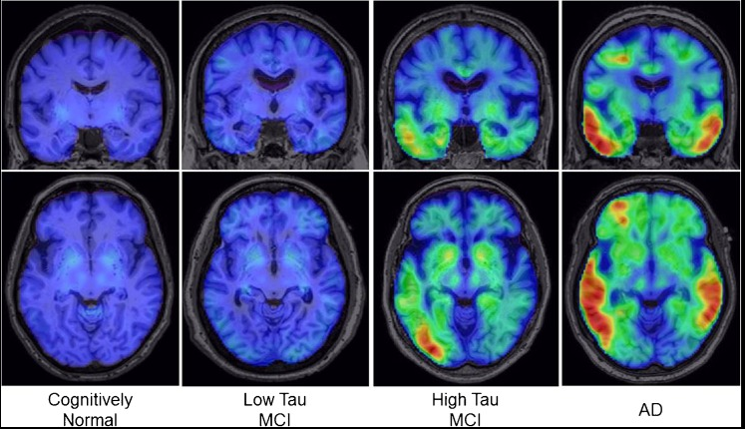

There is a high correlation, not necessarily causation, of tau protein abundance and AD diagnosis in patients. Increased uptake was observed in temporal, frontal, and parietal lobes; all regions play a key role in the function of cognition, memory, and other functions lost at the onset of dementia/Alzheimer’s. With varying degrees of how impactful amyloid plaques versus neurofibrillary tangles are to the cause of the disease, studies continue to be conducted.

A finding that remains constant in most research is the specific brain regions primarily affected by Alzheimer’s. The brain regions involved work together to make up the Default Mode Network, or DMN, which, when functioning normally, connects the posterior cingulate cortex (PCC), the medial and inferior temporal lobes (MTL and ITL), and the inferior parietal lobe (IPL) (Yildirim & Büyükişcan, 2019). Author Elif Yildirim also realized the importance of the medial temporal lobe in the progression of Alzheimer’s disease. His study showed that the DMN must function with two subsystems: the MTL, which is composed of the PCC, hippocampus, and parahippocampus, and the medial prefrontal cortex, which includes the PCC, ventral mPFC, and the inferior parietal lobe. The medial temporal lobe specifically correlates with memory, as seen by the increased firing rate in this region during memory retrieval. Yildirim found that many neurofibrillary tangles originated in the MTL structures, stating that this finding is “coherent with the clinical manifestation of Alzheimer’s Dementia,” (Yildirim & Büyükişcan, 2019, p. 3). This indicates that some interference in this area may be the cause of memory-deficit symptoms of the disease. In their study, a focus on the hippocampus revealed a reduced connectivity from this region to cortical structures in the brains of Alzheimer patients. Similarly, David Smith (2002), a scientist who linked the disease to the MTL as discussed in the previous paragraph, took particular notice of the hippocampus in his patients. Comparing part of the hippocampus of a healthy individual to one from a patient at the end stages of AD, it was found that it shrunk 66%, while the neuron count in the region decreased by 84% (Smith, 2002). This evidence suggests the hippocampus is highly affected by Alzheimer’s disease, and could be a key region to look further into when searching for a treatment.

While hundreds of thousands of clinical trials are being run currently, a definite cure has yet to be discovered. Clinical trials depend on participation of Alzheimer’s patients for their brains to be studied throughout the path of their disease (Alzheimer’s Association Staff, 2023). Animal studies are the more common form of pre-clinical research, allowing researchers to focus on mouse and rat brains as they have comparable structure to human brains. According to the National Institute on Aging [NIA] (2023), there are only 13 clinical trials using pharmacology that have made it to phases II and III; it is evident that there are many checkpoints for researchers to meet before adequate evidence of a promising clinical trial can be run. Most clinical trials target amyloid plaque build up and finding a treatment that will eliminate these in the brain. In an article from the *International Journal of Molecular Sciences*, Elodie Passeri and his colleagues looked into targets of creating curative therapeutics that would eliminate these amyloid plaques (Passeri et al., 2022). The scientist stated that these plaques are best to analyze when searching for a cure due to the AB oligomer buildup; this type of build up can be detected on brain scans much earlier than the first neurological signs of Alzheimer’s, giving hope at stopping the disease early. He also discusses the roadblocks researchers encounter using pharmacological treatments on the disease. The blood brain barrier provides protection to our brains, preventing unwanted substances and pathogens from crossing over and ultimately changing our chemical makeup in the brain. Because of this feature, many therapeutic drugs cannot cross and therefore cannot act on the buildup of plaques or tangles in the brain. Passeri discusses the benefit of using soft nanoparticles, which can target and possibly cross over that barrier.

Despite blood brain barrier challenges and lack of a definite cure, some scientists have had success with administering drugs to treat and delay symptoms of Alzheimer’s disease. Christopher van Dyck, the director of Yale’s Alzheimer’s Research Clinic, along with his team had a recent breakthrough with a drug called Leqembi™ (Macmillan, 2023). In the past year the FDA has approved administration of this drug to patients, which occurs through an IV injection every two weeks. Lecanemab targets amyloid plaques and reduces amyloid plaques along with cognitive deficits seen in patients with AD. A trial conducted by van Dyck showed that over the course of 18 months, participants with AD who received the Lecanemab treatment had slowed their cognitive decline by 27% (Macmillan, 2023). This drug is not freely sold or administered, and there are plenty more steps for these doctors to take in order to reduce side effects and effectiveness in the coming years. Nonetheless, this is a monumental step forward in treatment of Alzheimer’s Disease.

As mentioned, most current treatments of Alzheimer’s disease focus on prevention. There are numerous risk factors apart from genetics that can put someone at greater likelihood of developing the disease. A person’s lifestyle greatly affects their risk of developing AD (Mayo Clinic Staff, 2024). A lack of exercise, obesity, smoking, high blood pressure and cholesterol, and more components can increase the risk. Passeri reflects on some of these risk factors in his article (Passeri et al., 2022). He discusses two different types of risk factors: non-modifiable and modifiable risk factors. The most prevalent non-modifiable risk factor is age. As one gets older, their likelihood of developing dementia and being diagnosed with Alzheimer’s disease increases. This is in part due to the fact that even without dementia affecting the brain, brain volume, density, neuron count, and structure of white and grey matter changes (Passeri et al., 2022). Synapses in the brain are lost which immediately affects memory and cognitive functioning. As briefly mentioned, there is also a genetic component when calculating the risk of developing Alzheimer’s. If one had ADAD, or autosomal-dominant AD (previously described as early onset), the genes mutated are believed to be amyloid precursor protein (APP), presenilin 1 (PSEN1), or presenilin 2 (PSEN2) (Passeri et al., 2022). In the more common type of Alzheimer’s disease, which is SAD (sporadic type), the gene associated is APOE. This gene plays a pivotal role in transporting lipids in both the PNS and the CNS. Because of this key role, a mutation in its transport-function would result in a lack of homeostasis. The gene itself has three different alleles which are ε2, ε3, and ε4. Based on clinical studies that analyze the genes of those diagnosed with Alzheimer’s, it has been found that the ε4 allele is most common in these patients, making it a primary risk factor. This allele has been linked to a decrease in hippocampal volume and a mass of amyloid deposit build up. However, strangely enough, studies from Passeri’s journal reported that the ε2 allele actually decreased risk of developing AD.

Author Erin Bryant agrees with Passeri in her article regarding the role of genes being a risk factor (Bryant, 2021). She states that “25% of people carry one copy of APOE4, and 2 to 3% carry two copies” (Bryant, 2021, n.p.). Bryant looked into Dr. Li-Huei Tsai’s work which highlighted how presence of APOE4 can alter lipid metabolism, which will be discussed further with the modifiable risk factors. Tsai conducted a study using APOE4 skin cells and turning them into astrocytes. It was found that astrocytes made from this gene accumulated more unsaturated fatty acid chains than the control astrocytes made from someone’s skin cells that were not carriers of APOE4. Despite complementary studies regarding this gene’s presence being a risk factor, more studies must be conducted to verify a relationship between the presence of these alleles and Alzheimer’s disease (Bryant, 2021). The last non-modifiable risk factor is gender. Women are more likely to develop the disease which could be related to an abundance of lifestyle habits and other sex-related risk factors.

Modifiable risk factors should be the first step at prevention as it can be started early on and does not require approved therapeutic drugs. Cardiovascular health is an important area of concern when looking into Alzheimer’s disease. Having a weakened cardiovascular system or damage of any kind can hinder your neuronal health and in turn, become a risk factor for the development of any neurodegenerative disease (Passeri et al., 2022). Metabolism is also a regulatory system of homeostasis that us as humans have some impact over; our diets can be influential upon our neurological health. A source of energy for brain function comes from long-chain polyunsaturated fatty acids, or PUFAs. These lipids make up nearly 25-30% of the fatty acids in our central nervous systems. Breakdown of these fatty acids in the brain plays into cognitive functioning. Another lipid that is in relatively high abundance in the brain is cholesterol. While this cholesterol can be beneficial to increase or decrease membrane fluidity depending on the homeostatic need, too much cholesterol can harm us (Passeri et al., 2022). High cholesterol has been tied to cardiovascular disease, obesity, diabetes, and more recently seen, the diagnosis of Alzheimer’s disease.

**Figure 2**

*Alzheimer’s Disease Spectrum* (Passeri et al., 2022),

Copyright 2009, Nature Publishing Group, Copyright 2017, Yonsei University College of Medicine, Copyright 2009, Elsevier.

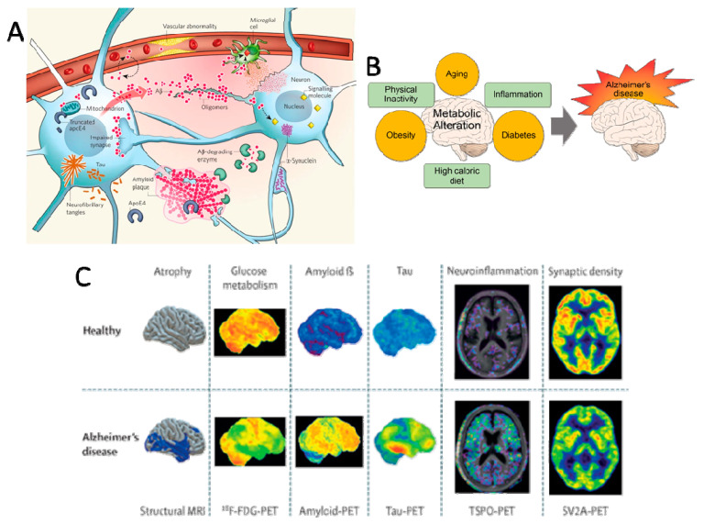

The figure above shows some common risk factors as described in the previous paragraphs, along with presence of brain components in Alzheimer’s patients compared to healthy individuals. Picture A shows the effects of APOE4 on the axon along with how amyloid plaques form here.

Although the amount of side effects and exact influence on the brain is unknown regarding Alzheimer’s, the impact on the loved ones of a patient with the disease can unfortunately be observed. Caring for someone with Alzheimer’s disease is a daunting duty that gets harder as time and the disease progresses; the gradual loss of a loved one can negatively impact all aspects of a person’s life. The task of caring for someone with any cognitively impairing disease can seem to turn into a full time job for lots of people. Luckily, there are plenty of support groups that provide help and advice to caregivers on how to best support while also keeping control and prioritizing their own life. According to the Centers for Disease Control and Prevention (CDC), around 80% of Alzheimer’s patients are cared for in the comfort of their own homes (CDC Staff, 2023). This allows for more flexibility for caregivers to work from home/complete domestic duties while simultaneously caring for their loved one, yet, it also can create a stressful, overwhelming space in the home. In 2019, the approximate total number of hours of unpaid caregiving was estimated to be near 18.5 billion hours (CDC Staff, 2023). Around 66% of caregivers are also women, while men make up about 34%. This statistic is somewhat daunting, as single women who are caregivers may struggle to financially support themselves, their loved one, or their children if they have any. The financial burden weighs heavily on caregivers since it’s another person to take care of, however, it is also more troublesome for those who only have one form of income.

Relationships between the caregiver and patient, or the patient and others around them, go through significant changes, as well. The loss of companionship and connection can be an emotional transition to go through for both parties. If you are caring for a patient, relationships with others may also become difficult due to lack of available time for them, or due to discomfort on their part of being around the patient. Besides feeling a difference in connection, the caregiver may experience a multitude of emotions throughout their journey of taking on this task. The Alzheimer Society lays out the feelings and also coping mechanisms to deal with them (Alzheimer Society Staff, n.d.). One of the most common emotions to feel is guilt. Symptoms of dementia and Alzheimer’s can become apparent far earlier than diagnosis, as described above. Family and friends of a patient with dementia might feel guilty for not recognizing the symptoms sooner or even for the way they treated this person prior to understanding the disorder. Lots of family members of Alzheimer’s patients describe a feeling of wanting to do more for the patient, but not feeling like they’re doing as much as they can. Another emotion commonly felt is the feeling of grief and loss. Loss of the relationship and of the person they were before the development of dementia can weigh heavy on the hearts of family and friends. What makes handling this emotion even harder is the lack of understanding of the patient, or even the constant reassurance/reminder that they have to give to the affected. It is a shared experience to feel frustrated as a family member of someone suffering. The constant reminding becomes exhausting, and trying to reexplain relationships, concepts, or any other memory that was lost with the onset of diagnosis can bring upon a lot of anger (Alzheimer Society Staff, n.d.).

Changes in relationships between the family members and the patient are most prominent, but an area that is often overlooked is the relationship between caregivers and other children or teens. The responsibility of taking care of the patient becomes number one priority, of course, which typically means attention from other family members is drawn back from the caregiver. Some signs of neglect have been recorded, leading to resent and a misunderstanding on the other siblings part.

Alzheimer’s disease is an ongoing mystery. New discoveries are constantly being made, giving hope to hundreds of thousands of patients, family and friends of these patients, and all of healthcare around the world. Positive strides towards a treatment, as well as discoveries on preventative measures are being conducted everywhere. At the forefront of neurodegenerative diseases, Alzheimer’s disease unfortunately continues to affect many, however, medical advancements create a positive outlook on the future of this disease.

**References**

Alzheimer Society Staff. (n.d.). *Understanding how your relationship may change*. Alzheimer Society of Canada. https://alzheimer.ca/en/help-support/i-have-friend-or-family-member-who-lives-dementia/understanding-how-your-relationship

Alzheimer’s Association Staff. (n.d.). *What is alzheimer’s?* Alzheimer’s Disease and Dementia. https://www.alz.org/alzheimers-dementia/what-is-alzheimers

Brosch, J. R., Farlow, M. R., Risacher, S. L., & Apostolova, L. G. (2017, January). *Tau Imaging in alzheimer’s disease diagnosis and clinical trials*. Neurotherapeutics : the journal of the American Society for Experimental NeuroTherapeutics. https://www.ncbi.nlm.nih.gov/pmc/articles/PMC5233632/

Bryant, E. (2021, March 16). *Study reveals how APOE4 Gene may increase risk for dementia | National Institute on Aging*. National Institute on Aging. https://www.nia.nih.gov/news/study-reveals-how-apoe4-gene-may-increase-risk-dementia

CDC Staff. (2023, June 30). *Caregiving for person with alzheimer’s disease or a related dementia*. Centers for Disease Control and Prevention. https://www.cdc.gov/aging/caregiving/alzheimer.htm

Cummings, J. L., Tong, G., & Ballard, C. (2019, February 12). *Treatment combinations for alzheimer’s disease: Current and future pharmacotherapy options*. Journal of Alzheimer’s disease : JAD. https://www.ncbi.nlm.nih.gov/pmc/articles/PMC6398562/

Knapskog, A.-B. (2021, April 29). *Alzheimer’s disease – diagnosis and treatment*. U.S. National Library of Medicine. https://pubmed.ncbi.nlm.nih.gov/33950641/

MacMillan, C. (2023, July 24). *Lecanemab, the new alzheimer’s treatment: 3 things to know*. Yale Medicine. https://www.yalemedicine.org/news/lecanemab-leqembi-new-alzheimers-drug#:~:text=Lecanemab%20works%20by%20removing%20a,Alzheimer%27s%20disease%2C%E2%80%9D%20says%20Dr

Mayo Clinic Staff. (2024, February 13). *Alzheimer’s disease*. Mayo Clinic. https://www.mayoclinic.org/diseases-conditions/alzheimers-disease/symptoms-causes/syc-20350447

Mendez, M. F. (2019, May 28). *Early-onset alzheimer disease and its variants*. Continuum (Minneapolis, Minn.). https://www.ncbi.nlm.nih.gov/pmc/articles/PMC6538053/

NIA Staff. (2023, December). *National Institute on Aging*. NIA-Funded Active Alzheimer’s and Related Dementias Clinical Trials and Studies. https://www.nia.nih.gov/research/ongoing-AD-trials

Passeri, E., Elkhoury, K., Morsink, M., Broersen, K., Linder, M., Tamayol, A., Malaplate, C., Yen, F. T., & Arab-Tehrany, E. (2022, November 12). *Alzheimer’s disease: Treatment strategies and their limitations*. International journal of molecular sciences. https://www.ncbi.nlm.nih.gov/pmc/articles/PMC9697769/

Smith, D. (2002, April 2). *Imaging the progression of alzheimer pathology through the brain*. Proceedings of the National Academy of Sciences of the United States of America. https://pubmed.ncbi.nlm.nih.gov/11929987/

WebMD Staff. (n.d.). *Alzheimer’s disease center: Dementia symptoms, diagnosis, and treatments*. WebMD. https://www.webmd.com/alzheimers/default.htm

Wenk, G. L. (2003). *Neuropathologic changes in Alzheimer's disease*. J Clin Psychiatry. https://www.psychiatrist.com/read-pdf/12701/

Yildirim, E., & Büyükişcan, E. S. (2019, Winter). *Default mode network connectivity in alzheimers disease*. Turk psikiyatri dergisi = Turkish journal of psychiatry. https://pubmed.ncbi.nlm.nih.gov/32594490/